Project Design Phase-II
Technology Stack (Architecture & Stack)

Date | 30 September 2026
Team ID | SWTID-2026-1669
Project Name | AI WEATHER WISE APL
Maximum Marks | 4 Marks

Technical Architecture:
The system uses a user interface, weather API, AI processing layer, backend server, and database to collect, analyse, and display real-time weather forecasts and alerts.
Example: Order processing during pandemics for offline mode:
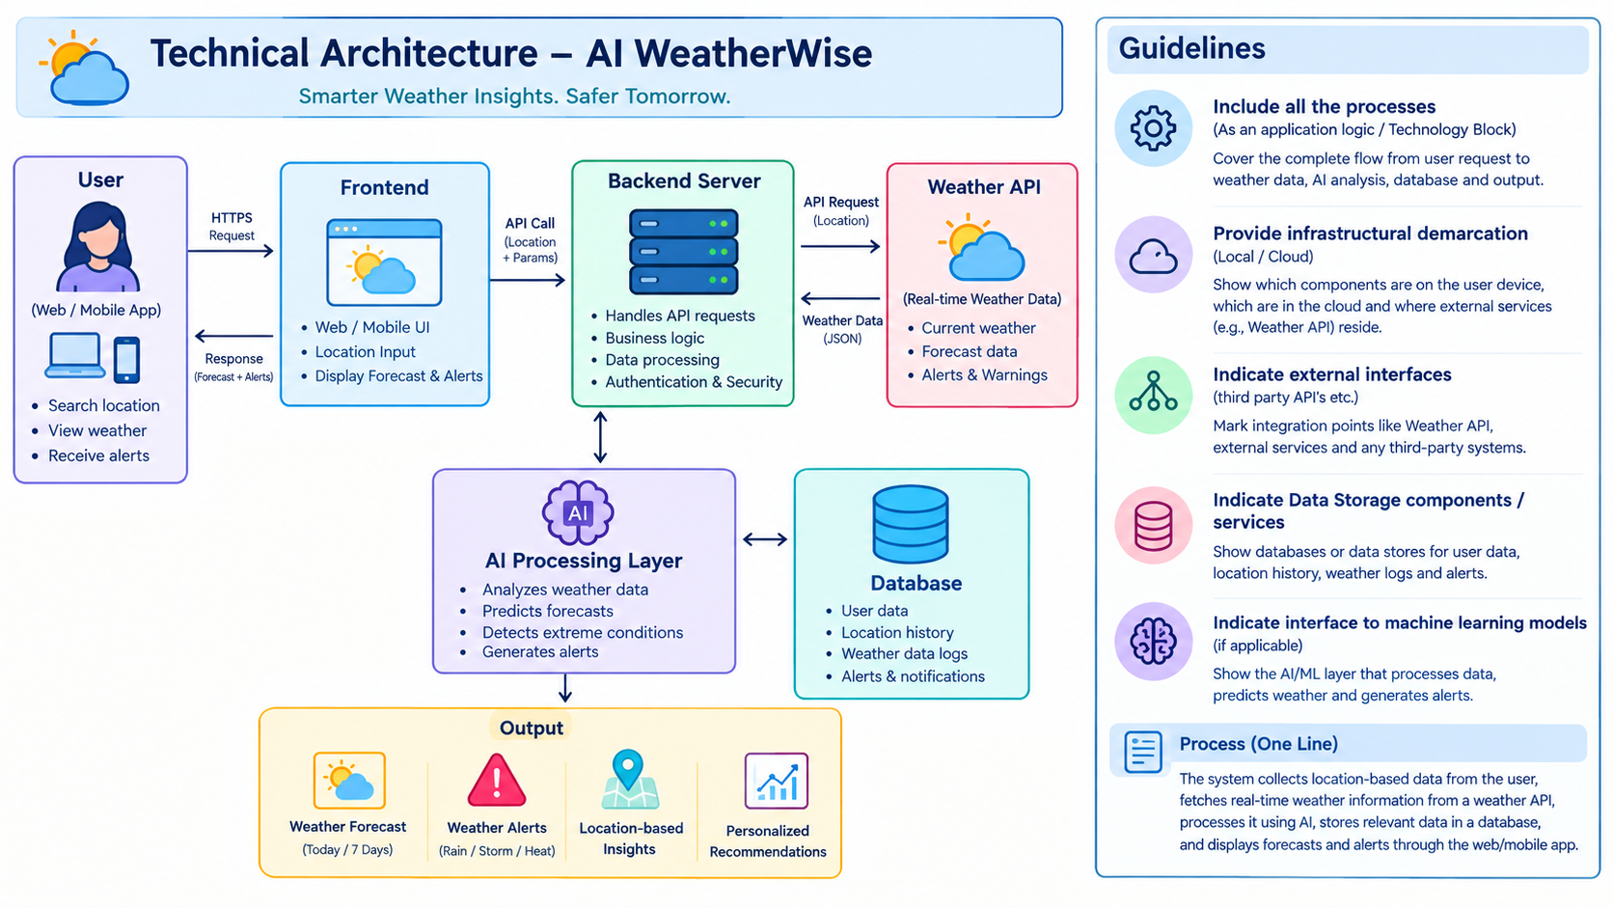
Table-1 : Components & Technologies:
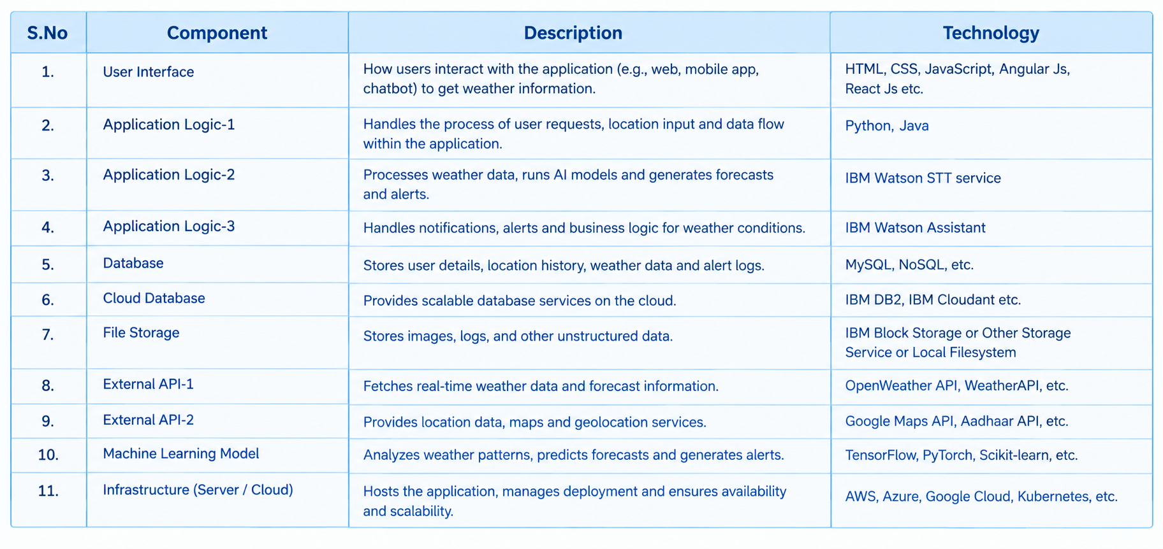
Table-2: Application Characteristic
